- What is your phd on??
  - What regions/modes of transport does it focus on?

- What goes into calculating transport sustainability? Just method, or also time/day
  - Which of the metrics mentioned are most easily calculated (by us))
  - ‘Global warming potential over 100 years’ - base level of co2
    - The intergovernmental panel on climate change
    - Italy bus impact paper - compares 8 impact categories
  - Particulate matter, carcinogenic potential
  - Do these calculations need to be specific to the region? I.e. is best practice changing calculations for cities
  - Is it just emissions, or does more go into it
- What are the most sustainable methods of transport overall in the south west?

How have you gone about contacting local authorities?

- In terms of a short-term mockup, is there a ‘minimum’ robustness you’d recommend our calculations meet? Or any ideas for mocking the calculations?

- How readily available is transport data?
  - Who do we ask for it?
  - How much does it cost/can we get it for free?
  - Have they found any gaps

- Have you looked at all into incentivising sustainable travel habits?

Notes
- Phd in uncertainty of sustainable transport
  - Lifecycle assessment - calculate the entire life system’s impact
- Lca of different fibres, the lca of sugar to decarbonise the uk suga industry
- Bike options:
  - Difference between conventional bikes and ebikes
  - Commutes every day by e-scooter
- Specialises in the WECA region
- Co2 equivalent
  - CO2 used as a baseline, methane can have 25x the greenhouse gas effect compared to the same amount of CO2
- West of england climate emergency action plan
  - Wants to go carbon zero by 2030
- Four different stages to analysing LCA
  - https://www.iso.org/standard/37456.html - how to carry out an LCA to a useful standard
  - Can you get copies via the university library?
  - A functional unit - one x’s worth of use , e.g. one person’s ravel per yer, one patch of road
- Land use, human toxicity, end of life, - which fa
- OpenLCA, brightway (python library) with activity browser - LCA generation and visualisation
- Department of psychology - how to get people who are into football to talk about sustainability
- His supervisor helped design the GWR environmental impact algorithm
- Route planning
  - Case studies: where people have been allowed to do route planning through the main transport company’s app
    - Mobility for service
  - Lots of interest with the west of england council
- Create personas for users - how would they react to the app? Look into work by the Design Council
- “Don’t infantilisie”
- Casual link between more sustainable transport options and boosts to local economies
  - Revenue increases for local businesses
    - No money on petrol/parking, not rushed by time restrictions on parking
He likes the product!!! Yay
Look at the research for CLA

Eco invent - life cycle standards - base lca’s on literature -

Big names alongside marcell mcmanus
Institute of Sustainability and Climate Change

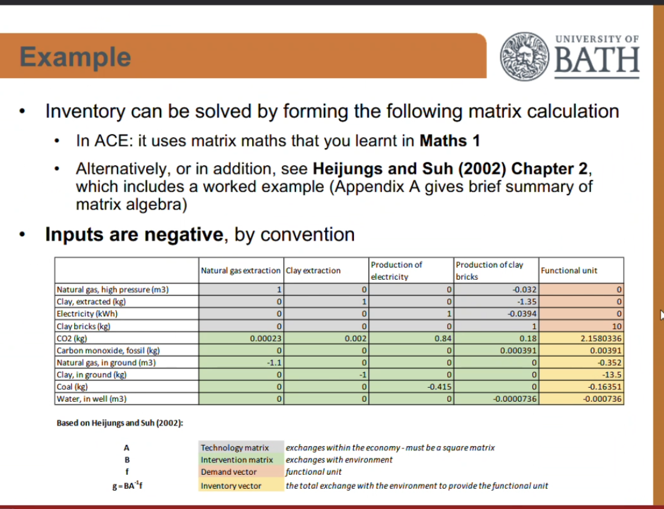

Links:
http://libproxy.bath.ac.uk/login?qurl=https%3A%2F%2Fbath-ac-primo.hosted.exlibrisgroup.com%2Fpermal…
https://www.youtube.com/watch?v=cRWuWETHmQM
https://www.youtube.com/watch?v=j3uLptvsxeA
https://learn.brightway.dev/en/latest/content/home.html
https://github.com/LCA-ActivityBrowser/activity-browser
https://pre-sustainability.com/files/2014/05/SimaPro8IntroductionToLCA.pdf

